**Math 120  
3.1 Quadratic Functions**

# **Objectives:**

1. Recognize and describe characteristics of parabolas.

2. Graph parabolas.

3. Determine a quadratic function’s minimum or maximum value algebraically.

4. Solve applied problems involving a quadratic function’s minimum or maximum value.

# **Topic #1: Quadratic Functions**

All quadratic functions come from the base function ______________________ and all quadratic functions possess certain properties. Consider the graphs of two quadratic functions:

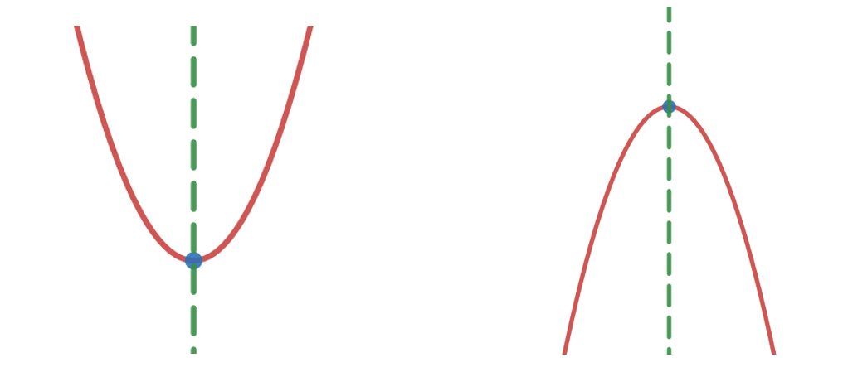

The quadratic on the left opens up, has a vertex, and an _________________ through the x-coordinate of the vertex. This parabola has a domain of _______________ and the range of values start at the y-coordinate of the vertex up through positive infinity. Since the parabola opens up, the vertex has a _______________________ (recall, a minimum occurs where a graph changes from decreasing to increasing).

The quadratic on the right opens down, has a vertex, and an axis of symmetry through the x-coordinate of the vertex. This parabola has a domain of ________________ and the range of values stop at the y-coordinate of the vertex moving up from negative infinity. Since the parabola opens down, the vertex has a ________________________ (recall, a maximum occurs where a graph changes from increasing to decreasing).

*Example #1* – State the Vertex, Axis of Symmetry, Domain, and Range of the Quadratic Function

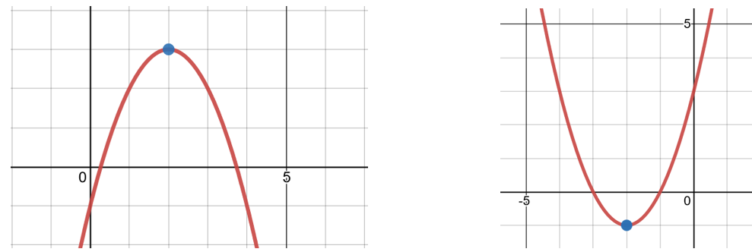

Vertex at the point _________________

The axis of symmetry is at _______________

The domain is ___________________

The range is____________________

The vertex is a ___________________ since the parabola opens down, the maximum value for the parabola is ___________________

and occurs when $x=2$.



Vertex at the point _________________

The axis of symmetry is at _______________

The domain is ___________________

The range is____________________

The vertex is a ___________________ since the parabola opens down, the minimum value for the parabola is ___________________

and occurs when $____________________$

# **Topic #2: Quadratic Functions in Standard/Vertex Form**

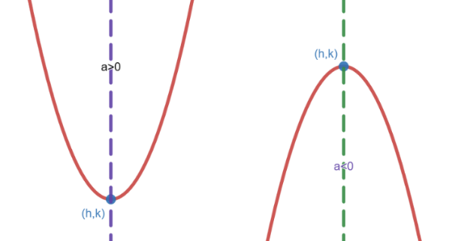The equation for quadratics in standard form is:

$$f\left(x\right)=a{\left(x-h\right)}^{2}+k;a≠0$$

Where the vertex is at the point ____________

If $a>0$, the parabola opens ______________

If $a<0$, the parabola opens _____________

*Example #1* – State the Vertex, Axis of Symmetry, Domain, and Range of the Quadratic Function

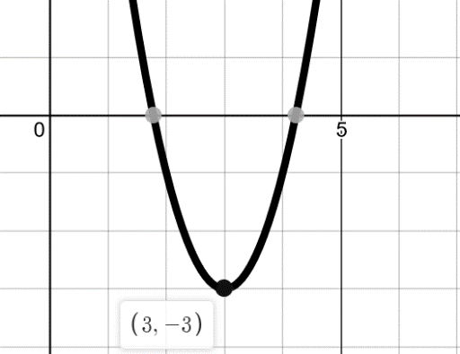a) $f\left(x\right)=2{\left(x-3\right)}^{2}-3$

This is in form, where $a= h=$ $k=$

The vertex is at the point _______________

Opens _________________since $a>0$.

The axis of symmetry is ________________

The domain is __________________

The range is ____________________

A graph confirms:

b) $f\left(x\right)=-2{\left(x+3\right)}^{2}+3$

This is in form, where $a= h=$ $k=$

The vertex is at the point _______________

Opens _________________since $a<0$.

The axis of symmetry is _______________

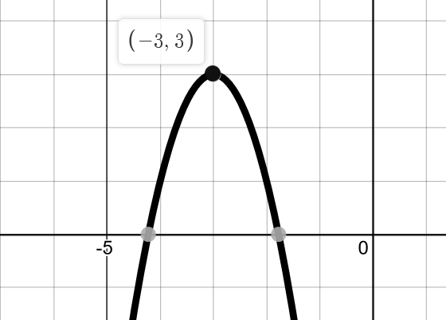The domain is __________________

The range is ____________________

A graph confirms:

c) $y-1={\left(x+2\right)}^{2}$

This is not in form, add 1 to both sides to make $y$ a function of $x$ and put in form:

This is in form, where $a= h=$ $k=$

The vertex is at the point _______________

Opens _________________since $a>0$.

The axis of symmetry is ________________

The domain is __________________

The range is ____________________

A graph confirms:

d) $f\left(x\right)=9-x^{2}$

This is not in form, rewrite so the square term is first:

This is in form, where $a= h=$ $k=$

The vertex is at the point _______________

Opens _________________since $a<0$.

The axis of symmetry is ________________

The domain is __________________

The range is ____________________

A graph confirms:

*Example #2* – Use the Conditions to Find the Domain and Range

a) The quadratic function has a vertex at $(-8,-6)$ and opens down.

The domain for any quadratic function is _____________

Since the quadratic opens down, the vertex is a _____________

Using the $y$-coordinate as the maximum value, the range is _____________________

b) The quadratic function has a vertex at $(-8,-6)$ and opens up.

The domain for any quadratic function is _____________

Since the quadratic opens up, the vertex is a _____________

Using the $y$-coordinate as the minimum value, the range is _____________________

# **Topic #3: Quadratic Functions in General Form**

The equation for quadratics in general form is:

$$f\left(x\right)=ax^{2}+bx+c;a≠0$$

Where the vertex is at the point ____________

If $a>0$, the parabola opens ______________

If $a<0$, the parabola opens _____________

The formula for the vertex is:

*Example #1* – Find the Vertex, Intercepts/Zeros, and Domain/Range of the Quadratic Function

a) $f\left(x\right)=3x^{2}+6x+10$

This is in general form, where $a=3, b=6, \text{and }c=10$

The vertex is:

The $y$-intercept is when $x=0 OR f(0)$:

The $x$-intercepts are when $f\left(x\right)=0$; we can try to factor or go to the quadratic formula:

The domain for any quadratic function is _____________

Since the quadratic opens up ($a>0$), the vertex is a __________________

Using the $y$-coorinate as the minimum value, the range is

________________

A graph confirms (notice the curve does not touch the $x$-axis):

Note: We can answer almost all of the questions by looking at the graph first. The zeros are not real, so we still need to use the quadratic formula to find them.

b) $f\left(x\right)=10x-x^{2}-9$

Rewrite to get into general form:

The vertex is:

The $y$-intercept is when $x=0 OR f(0)$:

The $x$-intercepts are when $f\left(x\right)=0$; we can try to factor or go to the quadratic formula:

The domain for any quadratic function is _____________

Since the quadratic opens down ($a<0$), the vertex is a __________________

Using the $y$-coorinate as the maximum, the range is

________________

A graph confirms:

*Example #2* – Use the Conditions to Find the Domain and Range

a) The quadratic has a minimum value of $-2$ when $x=7$.

The vertex is _________________

_________________ since it is a minimum.

The domain for any quadratic function is _____________

Since the quadratic opens up, the vertex is a minimum. Using the $y$-coorinate as the minimum value, the range is

___________________

b) The quadratic has a maximum value of $-2$ when $x=7$.

The vertex is _________________

_________________ since it is a maximum.

The domain for any quadratic function is _____________

Since the quadratic opens down, the vertex is a maximum. Using the $y$-coorinate as the maximum value, the range is __________________

**Topic #4: Applications of Quadratic Functions**

*Example #1* – Analyze a Quadratic Model

A ball is thrown upward and onward. The height of the ball, $f(x)$, in feet, is modeled by the function

$f\left(x\right)=-0.3x^{2}+2.1x+6$

where $x$ is the horizontal distance, in feet, from where the ball was thrown.

a) What is the initial height of the ball?

b) What is the maximum height of the ball? How far along the horizontal is the ball when at its maximum height?

We can use the vertex formula:

The vertex is the point ____________________

which tells us the maximum height of the ball is 9.675 feet. The ball reaches this height when it has travelled ____________________ along the horizontal.

c) How far does the ball travel on the horizontal before hitting the ground? Round to the nearest tenth foot.

When the ball hits the ground, $f\left(x\right)=0$. We can use the quadratic formula:

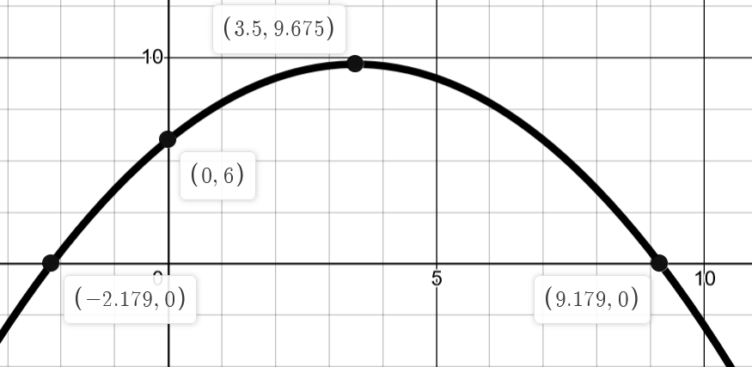

There are two zeros, but we only use the positive answer (since the ball only moves forward along the horizontal. The graph shows the ball will hit the ground about 9.2 feet away from where it was initially thrown.

*Example #2* – Build and Analyze a Quadratic Model

A person has 650 feet of fencing to enclose a rectangular area of land. One side of the land borders a river and no fencing.

a) Find a quadratic model that describes the area of land that the fencing encloses.

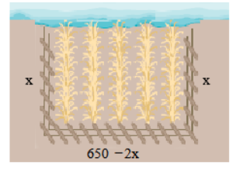The definition of area for a rectangle is $A=l*w$ OR

We can write this in general form:

b) What is the maximum area? What should the dimensions be to maximize the area?